
Department of Biomedical Engineering

BME 105L – Applications of ITC
Lab Manual
Semester: Spring 2026

Name: __________________________________
Student ID.: _____________________________
Batch: __________________________________

Submitted to:
Miss. Edina David
LAB 2
Date: | Student ID:
Learning Objectives

In this lab you will learn:
- How to create biomedical data sheets in Microsoft Excel
- How to apply formulas in Excel
- How to use IF functions in real hospital scenarios
- How to apply conditional formatting
- How to calculate medical equipment calibration dates
- How to calculate energy consumption of hospital equipment
Object: Excel-Based Biomedical Data Management System

1. Introduction
Microsoft Excel is a spreadsheet software used to store, organize, analyze, and manage data. In biomedical engineering, Excel plays a very important role in handling patient information, equipment maintenance records, and hospital energy usage analysis.
Hospitals and biomedical departments use Excel for:
• Patient vital monitoring records
• Equipment calibration tracking
• Inventory management
• Biomedical signal data logging
• Energy consumption analysis
Excel reduces human error and increases efficiency through formulas and automation.

2. Excel in Biomedical Engineering

2.1 Patient Vital Monitoring
In hospitals, patient parameters such as heart rate, blood pressure, and oxygen level must be monitored regularly. Excel can automatically:
• Detect abnormal values
• Classify patient condition (Normal / Warning / Critical)
• Highlight dangerous cases using color alerts
This reduces manual observation errors.

2.2 Logical Functions (IF Function)
The IF function allows Excel to make decisions.
Syntax:
=IF(condition, value_if_true, value_if_false)
In biomedical applications:
• If heart rate > 100 → Critical
• If calibration date expired → Overdue
• If power usage high → Alert
Logical automation is widely used in hospital management systems.

2.3 Equipment Calibration Management
Medical equipment must be calibrated regularly for accurate results.
Examples:
• ECG machines
• Ventilators
• Defibrillators
• Dialysis machines
Using Excel:
• Calibration dates can be tracked
• Next calibration can be calculated automatically
• Overdue equipment can be highlighted
This ensures patient safety and regulatory compliance.

2.4 Date Functions (EDATE & TODAY)

EDATE
Adds months to a given date.
Used for:
• Scheduling next calibration

TODAY
Returns current system date.
Used for:
• Checking overdue equipment
• Determining due dates automatically
These functions simulate real hospital maintenance systems.

2.5 Energy Consumption in Hospitals
Biomedical equipment consumes electrical energy.
Energy formula:
Energy (kWh) = (Power × Time) / 1000
Hospitals use energy analysis to:
• Reduce electricity cost
• Plan power backup
• Maintain efficient operation
Excel helps calculate daily energy consumption automatically.
Lab Task 01:
- OPENING EXCEL & SAVING FILE

Step 0.1: Open Excel
- Click Start Menu (Windows icon)
- Type Excel
- Click Microsoft Excel
- Click Blank Workbook

Step 0.2: Save the File Properly
- Click File (top left)
- Click Save As
- Choose This PC
- Choose a folder (Desktop is fine)
- File name:
Biomedical_Data_Management_System.xlsx
- Click Save

SHEET 1: PATIENT VITAL MONITORING

Step 1.1: Rename the Sheet
- Look at the bottom → you’ll see Sheet1
- Right-click on Sheet1
- Click Rename
- Type:
Patient_Vitals
- Press Enter

Step 1.2: Enter Column Headings
Click on each cell and type the following:

Cell | Type This
A1 | Patient ID
B1 | Patient Name
C1 | Age
D1 | Heart Rate (bpm)
E1 | Systolic BP
F1 | Diastolic BP
G1 | Date
H1 | Patient Status

Step 1.3: Make Headings Bold
- Click A1
- Hold Shift
- Click H1
- Press Ctrl + B

Step 1.4: Enter Sample Patient Data
Start from Row 2.
Enter 15 patients (P001 – P015).
Example data:
Patient ID | Patient Name | Age | Heart Rate (bpm) | Systolic BP | Diastolic BP | Date | Patient Status
P001 | Patient 01 | 45 | 78 | 120 | 80 | 1/1/2026
P002 | Patient 02 | 32 | 72 | 118 | 76 | 1/1/2026
P003 | Patient 03 | 58 | 92 | 145 | 90 | 1/1/2026
P004 | Patient 04 | 26 | 70 | 110 | 70 | 1/1/2026
P005 | Patient 05 | 63 | 98 | 160 | 95 | 2/1/2026
P006 | Patient 06 | 40 | 85 | 130 | 85 | 2/1/2026
P007 | Patient 07 | 51 | 88 | 140 | 88 | 2/1/2026
P008 | Patient 08 | 29 | 68 | 112 | 72 | 2/1/2026
P009 | Patient 09 | 47 | 90 | 150 | 92 | 3/1/2026
P010 | Patient 10 | 35 | 74 | 122 | 78 | 3/1/2026
P011 | Patient 11 | 60 | 96 | 158 | 94 | 3/1/2026
P012 | Patient 12 | 42 | 82 | 135 | 84 | 3/1/2026
P013 | Patient 13 | 55 | 89 | 142 | 90 | 4/1/2026
P014 | Patient 14 | 23 | 66 | 108 | 68 | 4/1/2026
P015 | Patient 15 | 65 | 100 | 165 | 98 | 4/1/2026

Step 1.5: Calculate Average Heart Rate
- Click on D18
- Type exactly:
=AVERAGE(D2:D16)
- Press Enter
NOTE:
Excel formulas always start with =

Step 1.6: Create Patient Status Formula
- Click H2
- Type:
=IF(OR(D2<60,D2>100,E2>140,F2>90),"Critical",
IF(OR(D2<70,D2>95),"Warning","Normal"))
- Press Enter

Step 1.7: Copy Formula to All Patients
- Click H2
- Move mouse to bottom-right corner
- Cursor becomes small +
- Drag down to H16

Step 1.8: Apply Conditional Formatting

Critical → Red

Warning → Yellow

Normal → Green
Steps:
- Select H2:H16
- Home → Conditional Formatting
- Highlight Cell Rules
- Text that Contains
- Type required word
- Choose color
- Click OK

Output of Lab Task 01:
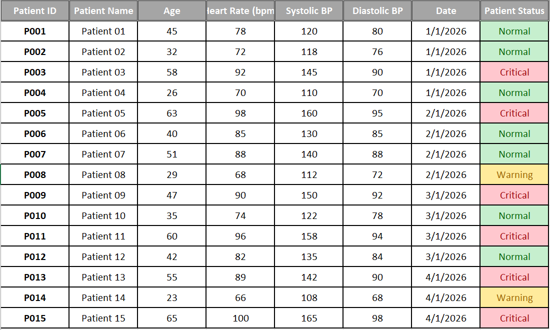
Lab Task 02:

SHEET 2: EQUIPMENT INVENTORY

Step 2.1: Create New Sheet
- Click + (bottom)
- Rename sheet:
Equipment_Inventory

Step 2.2: Enter Headings
Column | Heading
A1 | Equipment Name
B1 | Equipment ID
C1 | Department
D1 | Last Calibration Date
E1 | Next Calibration Date
F1 | Calibration Status

Make headings bold.

Step 2.3: Enter 15 Equipment Items
Example data:
Equipment Name | Equipment ID | Department | Last Calibration Date | Next Calibration Date | Calibration Status
ECG Machine | EQ-001 | Cardiology | 15-Nov-2025
Infusion Pump | EQ-002 | ICU | 10-Oct-2025
Ventilator | EQ-003 | ICU | 9-Jan-2025
Defibrillator | EQ-004 | Emergency | 20-Dec-2025
Patient Monitor | EQ-005 | ICU | 10-May-2025
Ultrasound Machine | EQ-006 | Radiology | 8-Dec-2025
Syringe Pump | EQ-007 | Neonatal ICU | 18-Nov-2025
X-Ray Machine | EQ-008 | Radiology | 30-Jul-2025
Anesthesia Machine | EQ-009 | Operation Theatre | 25-Sep-2025
Blood Pressure Monitor | EQ-010 | Ward | 12-Jan-2025
Pulse Oximeter | EQ-011 | Ward | 20-Nov-2025
Dialysis Machine | EQ-012 | Nephrology | 15-Aug-2025
CT Scanner | EQ-013 | Radiology | 6-Oct-2025
Oxygen Concentrator | EQ-014 | ICU | 12-May-2025
Glucometer | EQ-015 | Laboratory | 22-Nov-2023

Step 2.4: Calculate Next Calibration Date
- Click E2
- Type:
=EDATE(D2,6)
- Press Enter
- Drag down
NOTE:
EDATE adds months, used in real hospitals.

Step 2.5: Calibration Status Formula
- Click F2
- Type:
=IF(E2<TODAY(),"Overdue",
IF(E2<=TODAY()+30,"Due Soon","Valid"))
- Press Enter
- Drag down

Step 2.6: Conditional Formatting
• Overdue → Red
• Due Soon → Orange
• Valid → Green
Output of Lab Task 02:
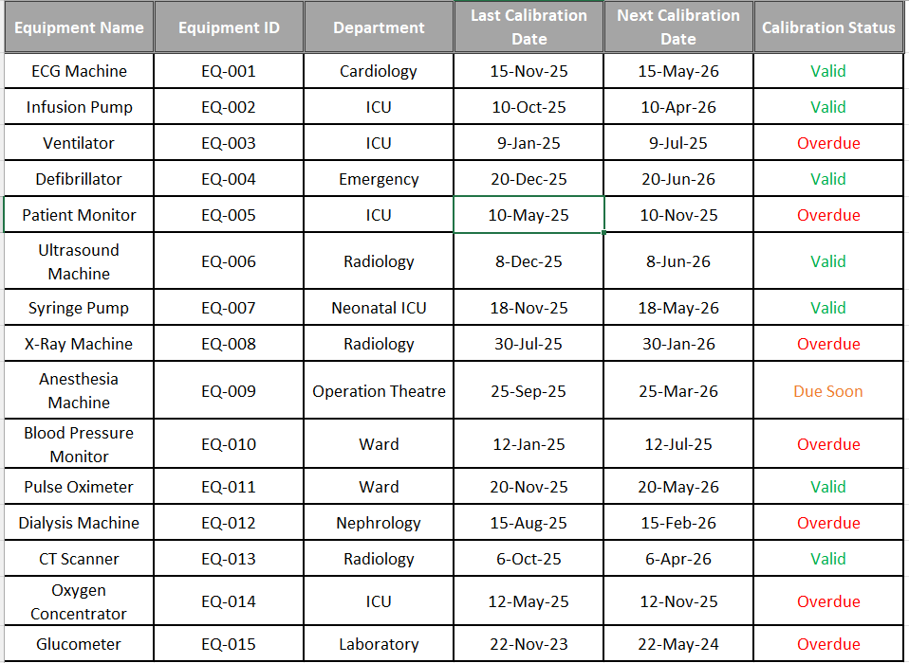
Lab Task 03:

SHEET 3: EQUIPMENT POWER ANALYSIS

Step 3.1: Create New Sheet
Rename:
Equipment_Power

Step 3.2: Enter Headings
Column | Heading
A | Equipment ID
B | Daily Usage Hours
C | Power Rating (Watts)
D | Daily Energy Consumption (kWh)

Step 3.3: Enter 15 Equipment Items
Example data:
Equipment ID | Daily Usage Hours | Power Rating (Watts) | Daily Energy Consumption (kWh)
EQ-001 | 5 | 200
EQ-002 | 8 | 150
EQ-003 | 12 | 500
EQ-004 | 3 | 1000
EQ-005 | 10 | 250
EQ-006 | 6 | 400
EQ-007 | 4 | 120
EQ-008 | 7 | 800
EQ-009 | 9 | 600
EQ-010 | 2 | 50
EQ-011 | 8 | 100
EQ-012 | 11 | 350
EQ-013 | 5 | 700
EQ-014 | 6 | 90
EQ-015 | 7 | 300

Step 3.4: Energy Formula
- Click D2
- Type:
=(B2*C2)/1000
- Press Enter
- Drag down
NOTE:
Watts × Hours = Wh
Wh ÷ 1000 = kWh

Output of Lab Task 03:
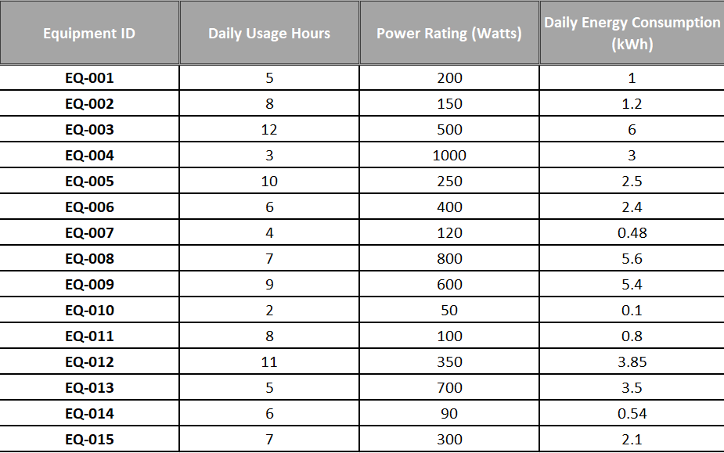

Conclusion
The main objective was to understand how Microsoft Excel can be applied in biomedical engineering for managing patient data, equipment maintenance, and energy analysis. We learned to use formulas like IF, AVERAGE, EDATE, and TODAY, apply conditional formatting, and automate status tracking. The lab showed how to calculate energy consumption and monitor patient vitals efficiently. These skills are directly applicable to hospital management, equipment calibration, and healthcare data analysis, improving accuracy and workflow efficiency.
Date: | Student ID:
Object: To analyze and improve the Biomedical Data Management System created during Lab 2 and apply advanced Excel logic in biomedical scenarios.
Post Lab Task 1

Patient Data Analysis
- Calculate the following:
• Maximum Heart Rate
• Minimum Heart Rate
• Average Systolic Blood Pressure
• Number of Critical Patients
- Create a new column named:
“Age Category”
Apply the following logic using IF:
• Age < 30 → Young
• Age between 30–50 → Adult
• Age > 50 → Senior
- Create a pie chart showing distribution of:
• Normal
• Warning
• Critical

Output of Post Lab Task 01:
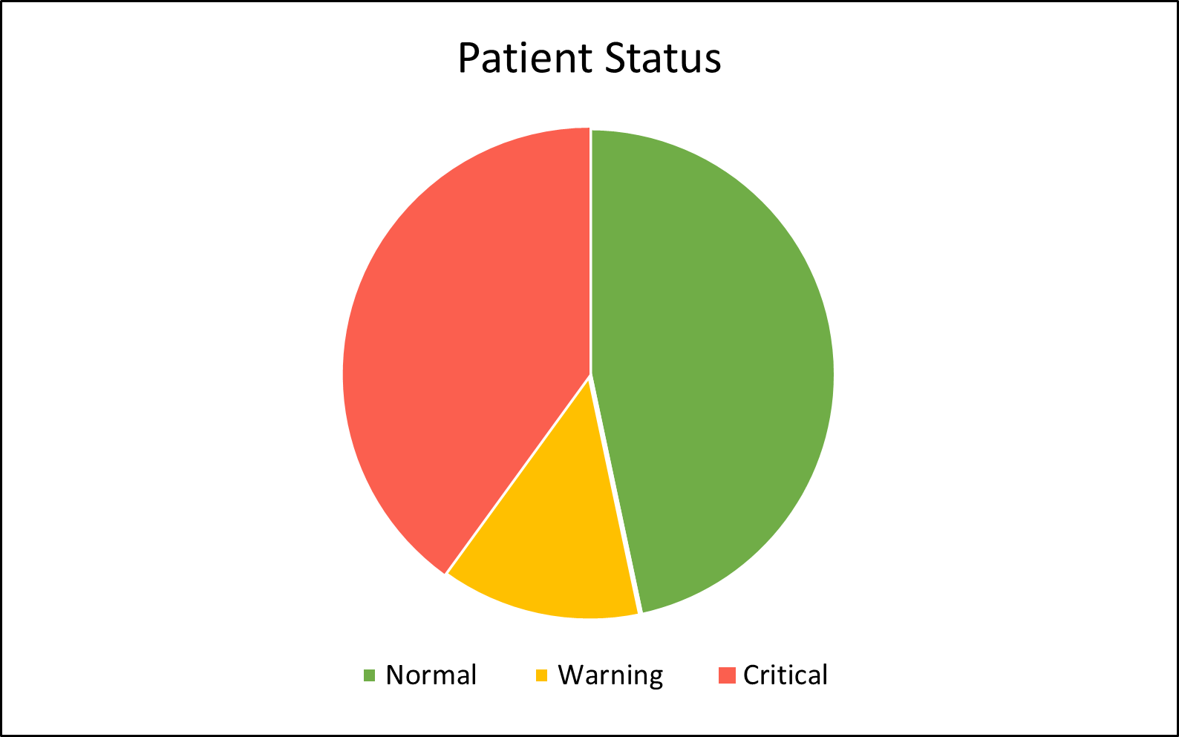
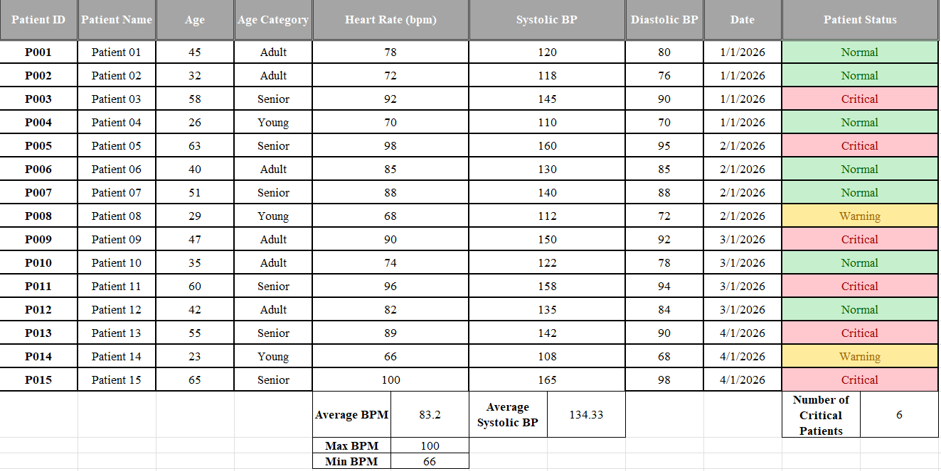

- Write 3 observations from your patient data analysis.
- The majority of patients fall under the Normal category (7 patients), indicating that most recorded vital signs are within safe limits.
- A significant number of patients (6 patients) are classified as Critical, mainly due to high blood pressure or abnormal heart rate values, which require immediate medical attention.
- Only a small portion of patients (2 patients) are in the Warning category, suggesting borderline vital signs that should be monitored closely to prevent deterioration.

Post Lab Task 2

Equipment Management Evaluation
- Count how many equipment are:
• Overdue
• Due Soon
• Valid
- Create a summary table showing:
| Status | Number of Equipment |
- If calibration period changes from 6 months to 12 months:
• Modify the formula
• Write the new formula
Next Calibration Date: EDATE (D2, 12)
Output of Post Lab Task 02:

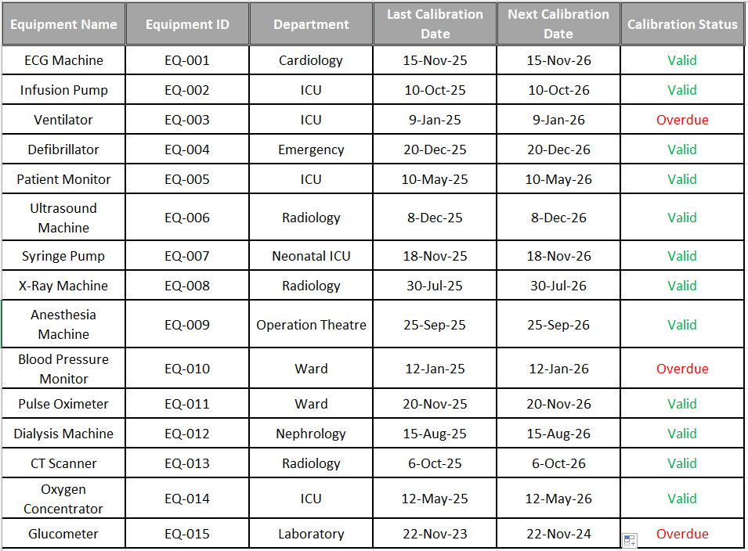
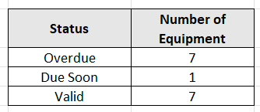
- Explain why calibration tracking is important in biomedical engineering.
Calibration tracking is vital because it ensures that life-saving medical devices provide accurate data and operate safely within a clinical environment. It acts as a proactive safety net, allowing engineers to identify and service Overdue units before they can fail during critical procedures or provide faulty diagnostic readings.

Post Lab Task 3

Energy Consumption Analysis
- Calculate:
• Total daily energy consumption of all equipment
• Equipment with highest energy usage
• Equipment with lowest energy usage
- If hospital electricity cost is:
Rs. 35 per kWh
Calculate:
• Total daily electricity cost
• Monthly electricity cost (30 days)
Output of Post Lab Task 03:
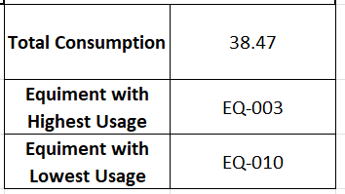
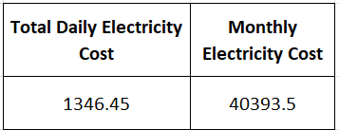

- Suggest 2 methods to reduce hospital energy consumption.
Equipment Upgrades: Replace old, high-power machines with energy-efficient models and turn them off when not in use.
Smart HVAC Systems: Use sensors to automatically adjust cooling and airflow based on how many people are in the room.

Critical Thinking Questions
- What would happen if TODAY() function was removed from calibration formula?
If TODAY() function from that calibration formula is removed, the formula will break and return a an error because Excel won't know what to compare the date in cell E2 against.
- Why is automation important in hospital systems?
Automation is critical because it shifts the focus from administrative maintenance to patient care. It serves as a safeguard against human error while optimizing the limited resources of a healthcare facility.
- How can Excel reduce medical errors?
Excel serves as a powerful tool in a hospital environment to mitigate risks and ensure high standards of care. By transforming manual logs into automated systems, it reduces the risk of human error drastically.
- Suggest one improvement to this Biomedical Data Management System.
We can add the Last Service Provider column giving the info about the Technician or Service Vendor. Having the contact info of the service provider for each equipment will save us from digging through paper files to schedule the technician.

